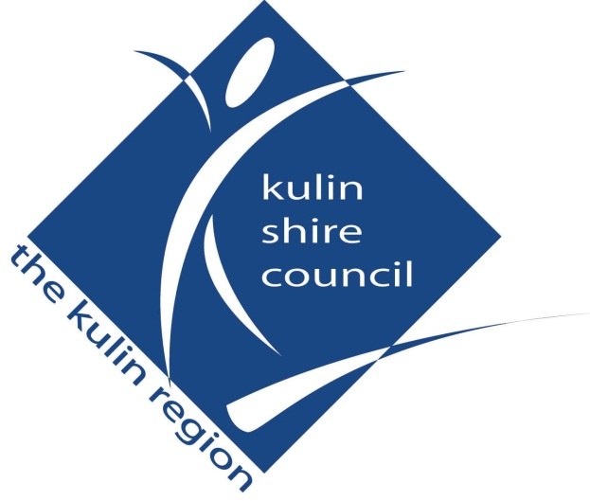

NOTICE OF MEETING

Please be advised that the Kulin Shire Council

Annual Electors Meeting

will be held on
Tuesday 11 February 2025
commencing at 5:30pm

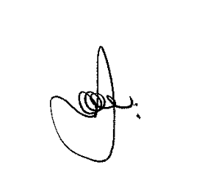
Alan Leeson
Chief Executive Officer
14 January 2025

DISCLAIMER
The advice and information contained herein is given by and to the Council without liability or responsibility for its accuracy. Before placing any reliance on this advice or information, a written inquiry should be made to the Council giving entire reasons for seeking the advice or information and how it is proposed to be used.
Please note this agenda contains recommendations, which have not yet been adopted by Council.

ORDER OF BUSINESS

- OPENING COMMENTS & ANNOUCEMENTS

- RECORD OF ATTENDANCE / APOLOGIES / LEAVE OF ABSENCE

- CONFIRMATION OF MINUTES OF PREVIOUS MEETINGS
- Annual Electors Meeting – 20 December 2023

- BUSINESS ARISING FROM MINUTES

- ANNUAL REPORT FOR THE PERIOD ENDING 30 JUNE 2024
- 2023/2024 Annual Report

- QUESTIONS WITHOUT NOTICE

7 MEETING CLOSURE

